**Experiment 1**

**Student Name:** Yash Gupta

**UID:** 20BCS5009

**Branch:** CSE

**Section/Group:** 20BCS_MM-807 / B

**Semester:** 5

**Subject Name:** Project Based Learning in Java Lab

**Aim/Overview of the practical:**

**Code:**

package Array;

import java.util.*;

public class Arremp {

//import java.util.*;

//public class HelloWorld {

public static void main(String[] args) {

int empno[] = {1001,1002,1003,1004,1005,1006,1007};

String name[]={"Ashish","Sushma","Rahul","Chahat","Ranjan","Suman","Tanmay"};

String JoinDate[]={"01/04/2009","23/08/2012","12/11/2008","29/01/2013","16/07/2005","1/1/2000","12/06/2006"};

char d_code [] = {'e','c','k','r','m','e','c'};

String dept[]={"R&D","PM","Acct","front","Desk","Engg","Manufacturing","PM"};

int basic [] = {20000,30000,10000,12000,50000,23000,29000};

int hra [] = {8000,12000,8000,6000,20000,9000,12000};

int it [] = {3000,9000,1000,2000,20000,4400,10000};

String designation = null;

int da=0;

int salary = 0;

int index = -1;

// int emp= Integer.parseInt(args[0]);

// System.out.println(emp);

//for(int k=0;k<empno.length;k++){

// if(args.length>0) {

String s = String.*valueOf*(1002);

int emp = Integer.*parseInt*(s);

// int emp = empno[k];

// System.out.println(i);

// }

for(int i=0; i<empno.length; i++)

{

if (empno[i]==emp)

{

index=i;

}

}

if (index==-1)

{

System.*out*.println("There is no such employee." +emp);

}

else

{

char code;

code=d_code[index];

switch(code)

{

case'e':

designation="Engineer";

da=20000;

break;

case'c':

designation="Consultant";

da=32000;

break;

case'k':

designation="Clerk";

da=12000;

break;

case'r':

designation="Receptonist";

da=15000;

break;

case'm':

designation="Manager";

da=40000;

break;

default:

designation="Invalid";

da=0;

}

salary=basic[index]+ hra[index]+da-it[index];

System.*out*.println("Emp No" +" "+"Emp Name" +" "+"Department"+" "+"Designation"+" "+"Salary");

System.*out*.println(empno[index]+" "+name[index]+" "+dept[index] +" "+designation +" "+salary);

}

}

//}

//}

}

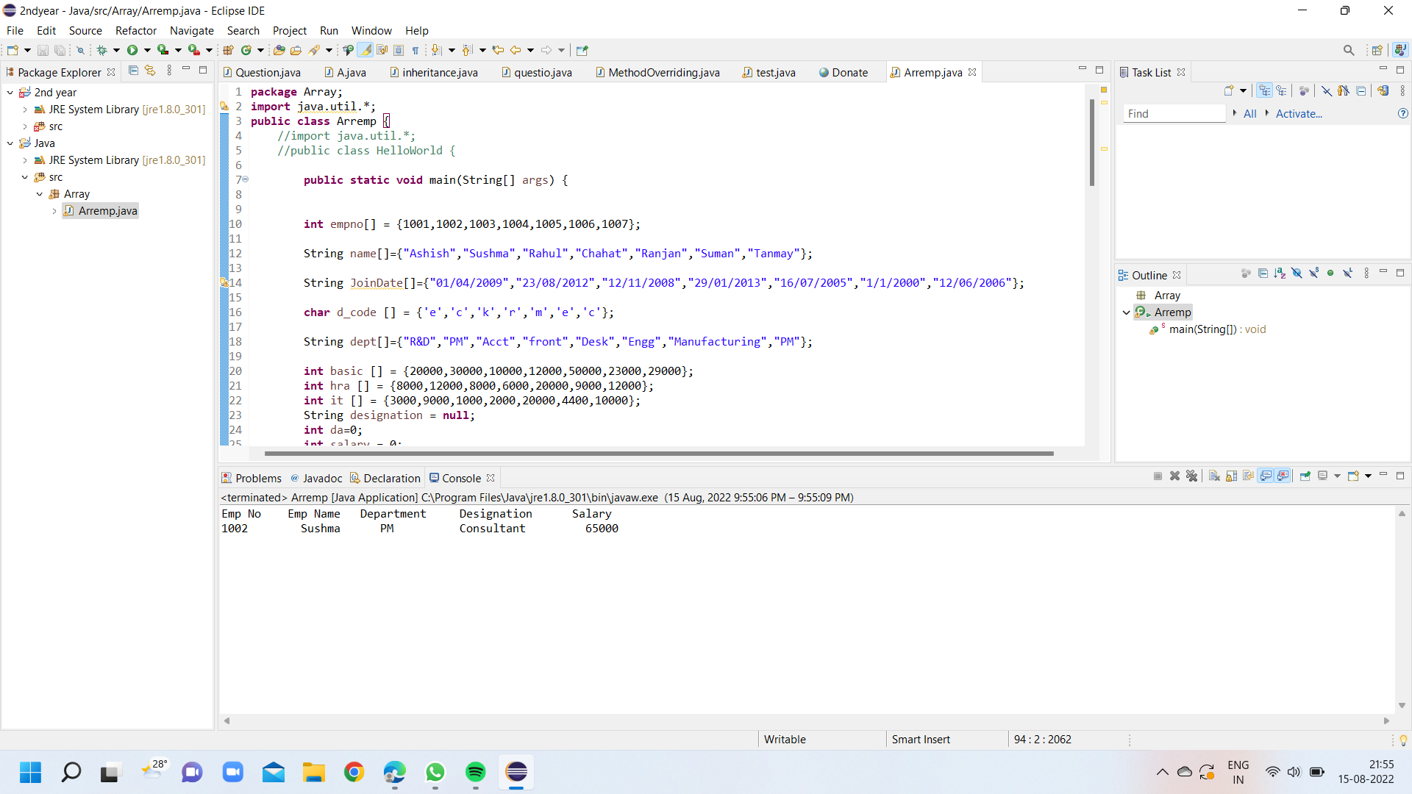

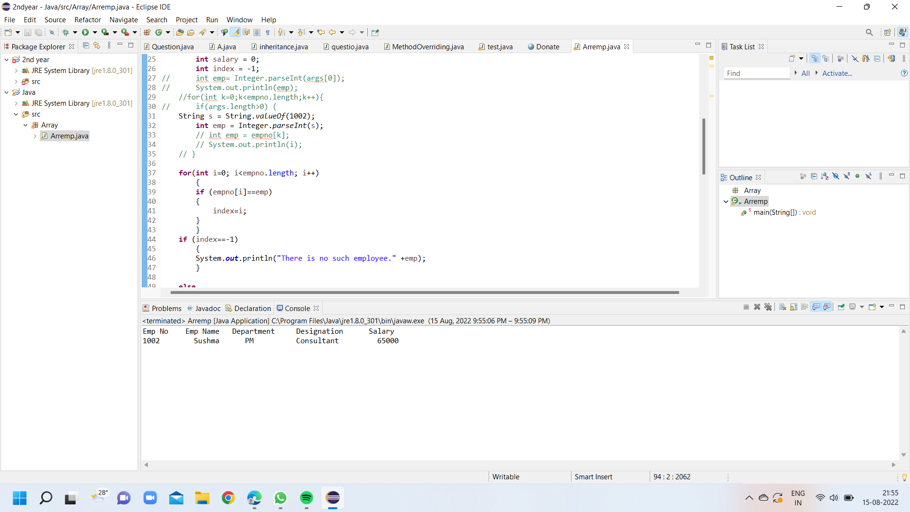

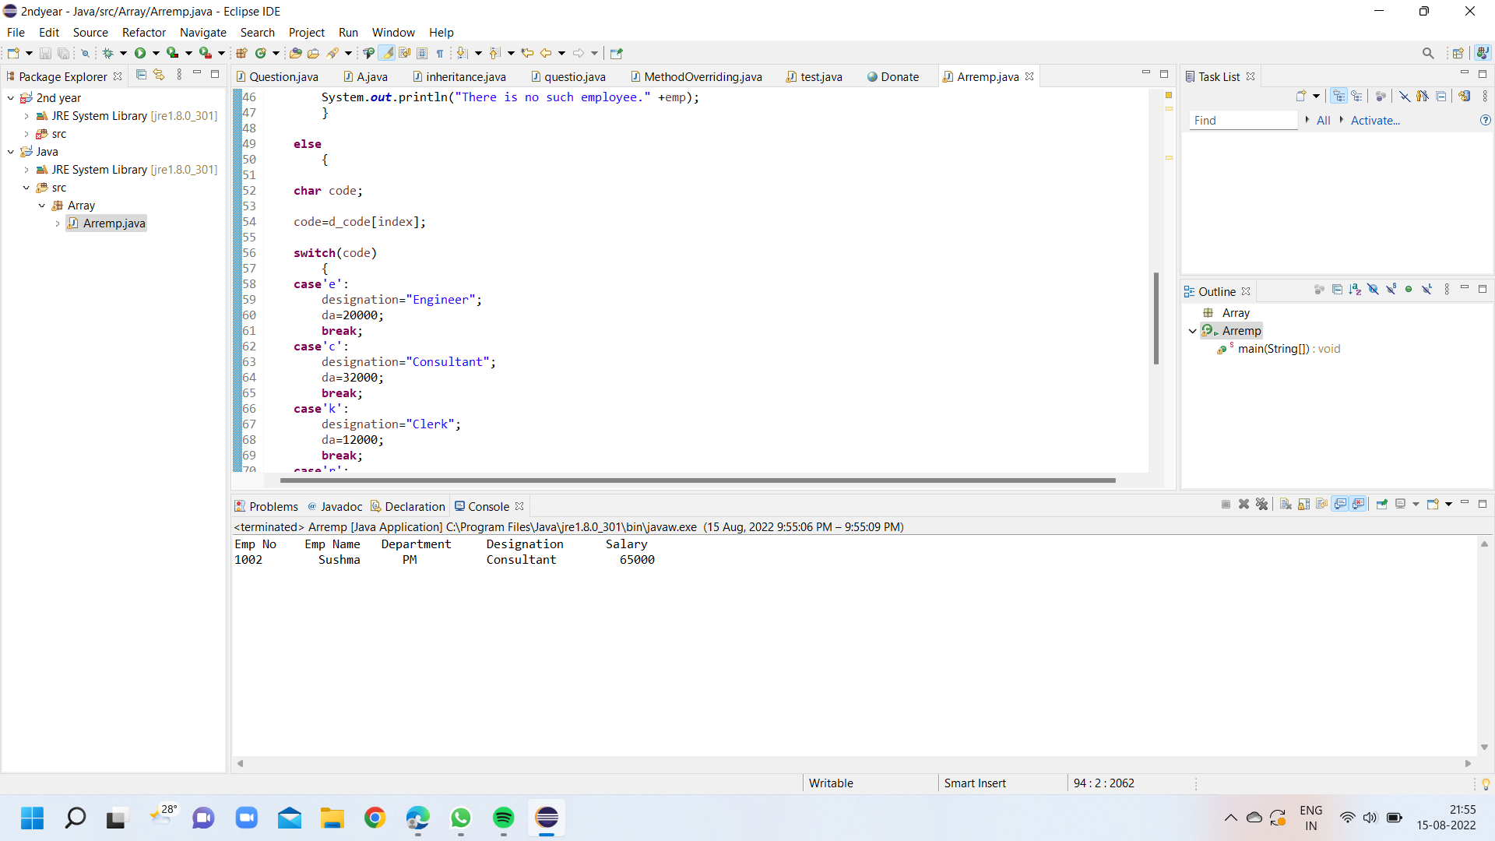

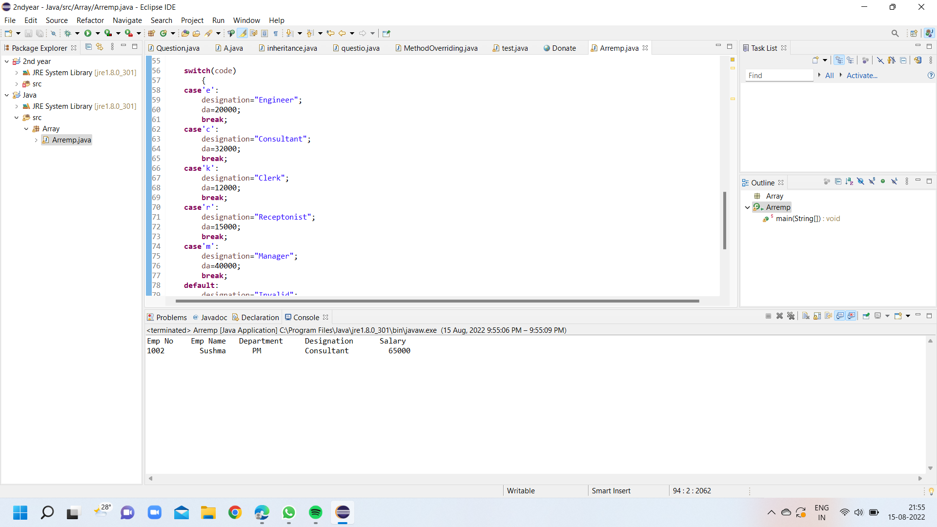

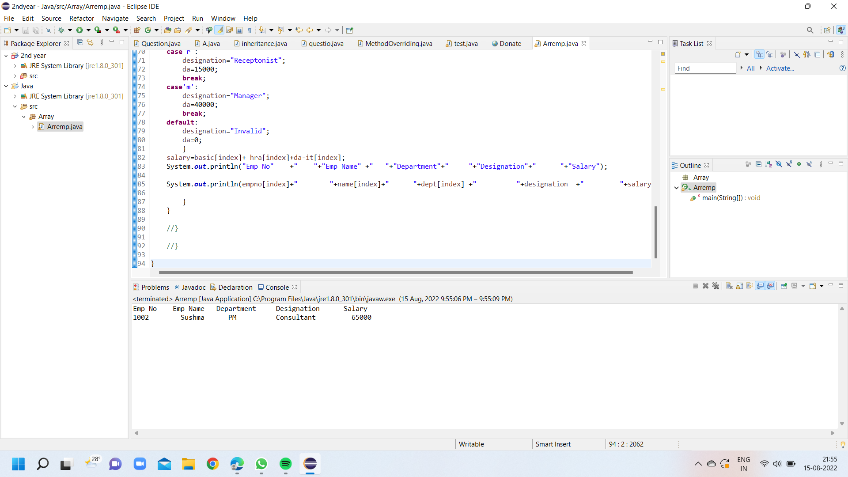

**Output:**

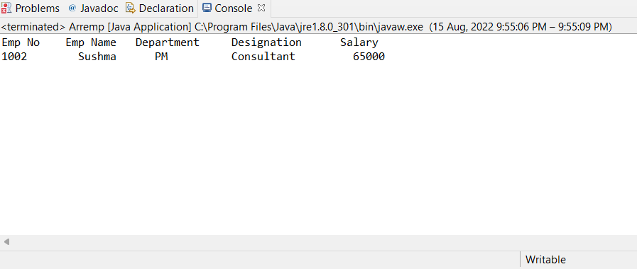

**Evaluation Grid (To be created as per the SOP and Assessment guidelines by the faculty):**

|  |  |  |  |
| --- | --- | --- | --- |
| Sr. No. | Parameters | Marks Obtained | Maximum Marks |
| 1. |  |  |  |
| 2. |  |  |  |
| 3. |  |  |  |
|  |  |  |  |